July
Newsletter

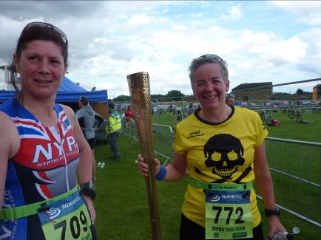

The Olympics are nearly here!

More torch pictures inside ...

WEST HULL LADIES RRC
COMMITTEE MEETING 6/2/2012

West Hull Ladies Committee Meeting

Minutes Monday 2nd July 2012

Attendees: Amanda Dean, Ann Holmes, Debbie Watson, Sandra Holdsworth

Apologies: Jo, Louise, Victoria, Annette, Verity (Katy, Geri, Shem)

- Club Name on Race Entry Forms.
On the JT Hull race, every lady had a different name against their race. This makes it much more difficult to copy the results into the feedback. It was agreed that we should enter races under the name: West Hull Ladies
It was noted that the Great North Run has a drop down selection box which lists West Hull Runners. Action: [Ann has contacted GNR]

- Away Nights
It was agreed that these would only be successful if a mid distance route could be arranged. Verity and Sandra volunteered to lead the July mid distance route.
Sandra offered to lead the mid distance routes in the future which is very much appreciated. Amanda and Sandra will co-ordinate routes and include Kate who hopefully will be able to take a short route. There was discussion of the August away route which will be difficult due to holidays.

- Barefoot Running Workshop (18/08/12 York)
This will be advertised in the July Newsletter. Action: Amanda to forward email with the poster to Ann [Done].

- Club participation in Cross Country Events
We are interested in this but do not have information about the events or how to contact the organiser(s). Action: Amanda will email Beverley AC and ask for a contact/information. [Done – awaiting response]

- Officers’ Reports
Nothing to report.

- Any Other Business
- Debbie has come across a website link for West Hull Ladies which is out of date, e.g. including a club phone number. Action: Debbie will search again and email the link(s) to the club.
- It was suggested that ‘RRC’ be added to the next order of club vests/T shirts as there are times that ladies have been asked what ‘West Hull Ladies’ Action: This needs further discussion when a fuller committee is available.
- It was suggested that the favourite training sessions are the Hill training and Intervals. A discussion ensued and we agreed to try 2 interval sessions, 1 Hill training and 1 combined Fast K - Fast M session for the next month.
Amanda would continue as Hill training leader. Debbie and Ann would each take an interval session and Verity would combine the Fast K and Fast M session (with timing help).
- August training and holidays. Action: Amanda will email to find out the training officers’ August availability and create a training schedule to fit round the holidays.

Champagne League Presentation – Lockington Village Hall Tuesday 17th July 8pm

There will not be the usual presentation evening at the Golf club this year and therefore, at the last race in Lockington, CoH will present as many of the prizes as possible.


STOP PRESS!

Shem has had her baby – Oliver, born 7 pound and 10 ounces. Geri tells us she has a ‘rough ride’ but all is well, and that Shem is planning on doing a half marathon in January – what a come back!

Many, many congratulations, Shem!

The RW Complete Guide To Stretching
Thanks for Runnerworld.com for this one – come on, ladies – you know you should, so here’s how ...

Remember:
- Don’t stretch cold muscles. Stretch after a run than before.
- Do stretch lightly before speedwork, after a 10-minute warm-up jog.
- Ease into each stretch: don’t bounce or force it.
- Before speedwork, hold each stretch for 10-15 seconds.
- After a run, hold each stretch for 30 seconds; repeat once or twice on each leg.

1. Hamstring  Keep your upper body relaxed and both legs straight as you pull one leg towards you. A variation: lying as before, bend the upper knee in towards your chest. Holding the cord around the foot of the bent leg, push away with the foot, trying to straighten the leg against the tension of the cord. You should feel the stretch higher up the hamstring. | 
2. Glutes  Keep the ankle of your front leg just below your knee and ensure that you’re close enough to the wall for your lower back to be off the floor. As gravity gently brings your lower back towards the floor, you’ll feel a stretch in the muscles around the side of your buttocks. Adjust the angle of your hips and front knee to intensify the stretch. | 

3. Groin  Hold your feet and gently use your leg muscles to move your knees towards the ground. Keeping a straight back and bringing your feet closer to your body intensifies the stretch. | 

4. Gastrocnemius (upper calf)  Keep the back leg straight and push the back heel into the ground. Keeping a straight upper body and gently lifting up your hips helps. There shouldn’t be much pressure on the front foot. | 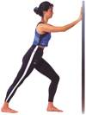

5. Soleus (lower calf)  Stand closer to the wall and bend one leg, keeping the foot flat on the floor. You should feel a stretch in your lower calf. Leaning towards the wall intensifies the stretch; there should be little pressure on the other foot. | 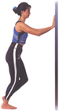

6. Iliotibial band  Place one foot around the other, with both feet flat on the ground. Keeping both legs straight, lean your hips towards the side of your rearmost foot (so, if your right foot is rearmost, lean your hips to the right). You should feel the stretch down the outside of your leg and around your hip – if you are very stiff, it may take a few times before you feel anything. | 

7. Hip flexor  Keep your hips squared forwards and your upper body vertical; slumping forwards reduces the stretch. | 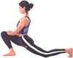

8. Quads  Flex your foot and keep your body straight to maximise the stretch through the front of your leg. You can put one hand on a wall if you need balance. | 

Three-Minute Stretching
Hold each of these stretches for 15 seconds per side if you’re pushed for time – it’s better than nothing!

Just a thought ...
I’m not sure about the reactions we might get doing the first three stretches before our fast mile on Cottingham Road ...!!

Run Strong • Run Free:
An introduction to the science and art
of barefoot running workshop
Saturday 18th August 2012
info@barefootrunninguk.com tel: 0845 226 7302 www.barefootrunninguk.com
Is your running disrupted by:
Recurring injuries?
Niggling pains?
An awkward/uncomfortable running gait?
Do you feel that something is missing?
Join us on our one day workshop to discover how to improve your running form for a more comfortable ride!
Workshop Cost: £90.00
For more information or to book your place please
visit our website www.barefootrunninguk.com

Melbourne Centre, Escrick St, Fishergate, York, YO10 4AW

Limited spaces available
based on our book with the same title
We will be covering:
•  Misconceptions of barefoot running
•  How to get started
•  Human Anatomy & biomechanics
•  Types of breathing
•  Optimum alignment in relation to running
•  Optimum running technique
•  Injuries
•  Barefoot running and its role in achieving balanced movement and improved performance
•  Concepts/myths/opinions surrounding “minimalist” shoes
•  Different terrains/weather and the accompanying challenges
•  Useful drills and exercises
PLUS individual feedback on your technique
Book price - £14.99 + p&p

Champagne League

Jill

Since the last time we reported from the Champagne League, we have done the dreaded Waudby Green 8.4 miles with the cardiac hill!!

Me and Zoe were absolutely dreading this one as I had never run beyond 7 miles and Zoe around 6 miles. We decided that we had firstly to get some trail trainers, and secondly needed to recce the route to make sure that we could get around it without collapsing! So on the week before the event, we went armed with map, and trail trainers around the route (which I had to replace as the originals gave me blisters…thank goodness for compeed!). We were soooo glad that we did this because it gave us some markers to run to on the day.

I have to say that I laughed out loud at my handicap which was only three minutes less than Zoe’s (now known as ‘speedy legs’ Jameson), and 19 minutes off the scratch time….but I suppose that was a result of my reasonable run in the previous race, where I had actually scored some extra points, and come about 13thbecause of the staggered start (shock horror!).

It was quite a hot day and the first two miles of the run were really really hard. Zoe passed me just before the cardiac hill at Eloughton Dale, and Amanda zoomed passed me in the last two miles down the hill back towards nut wood.

Despite being passed by almost the whole field, I was really pleased to get round and still be able to walk the next day…perhaps due to jumping into a cold bath when I got home. (This is apparently what Olympic athletes do to help recovery…which is the only thing that links me to proper athletes!). I think a glass of milk helps too!

In the race Zoe (speedy legs) Jameson was right on her handicap so scored lots of points both individually and for the team. After having had some brilliant runs in the league, Verity had a difficult run at Waudby Green, having an asthma attack in the first few miles, and really bravely carried on to finish.

We have now completed nine out of the ten runs together as a team and when it comes to grit and determination, for me Verity’s run represented an amazing feat of endurance. Had she not finished she would have not been able to take advantage of the handicapping in the next race at Kiplingcoates which resulted in Verity and Zoe coming first and second in the handicapping, again scoring a shed-load of points for them individually and for the team. This was a good thing as I was nowhere near my handicap time, but actually really pleased with my run, as most other people didn’t make their handicap either. This was probably because it was a bit muddy.

The result of all this is that our team ‘Thunder-girls are go’ are running first in the team event by two points, so there is all to play for in the final race on 17th July!

Current situation is Verity is 2nd Zoe 3rd Amanda 5th and me 13th in the ladies event out of 53 with one event to go J.

All in all the Champagne League is a really good event, and I think that it has made a huge difference to our running, in terms of endurance and confidence. I started off thinking ‘never again’ when I first started running the events, but the more I have done the league, the more I am thinking that I might even do it again next year. Zoe loves running off road, and actually when you get used to it, running on tracks does not jar your joints as much as running on the road. The nice things about taking part have been meeting other runners from other clubs, getting lots of support and encouragement from the other runners, running in some lovely countryside, and also getting to know Amanda and Verity much better. But…I still have not got the significance of this being to do with ‘champagne’…more like lots of mud and sweat???

Jill

Walkington 10k

Debbie

I found myself to be the lone representative for WHL on Friday evening, the field was closed to cars due to the weather and an earlier email from Beverley ac suggested runners shared lifts. Roger dropped me off and I joined the queue for the loos and went in search of familiar faces. I saw Stella and we chatted waiting to start.
The first two miles were tough, there is a downhill stretch in the first mile, Stella zoomed past me! and then there is a gradual climb which I always forget about. I was trying to remember the last time I did hill training. At 3 miles I had disposed of all negative thoughts and got on with it. I saw Sandra and tried to smile for the camera and made use of another downhill section. The weather was warm and sunny so pleasant running conditions, 4 and 5 miles passed and the last stretch is downhill but its a bit like the last stretch at beverley 10k not as easy as it looks, I pushed and dug deep and thought I would make up as much time as possible because of the slippery conditions on the path and field at the finish. The field was very soggy a lot of people seemed to charge right through the mud but I hoped I had done enough to get under 48mins. I was delighted to pass under the clock at 47.24 and come first in my category with a chip time of 47.08.
Thanks to Sarah Tock who cheered me at the water station and someone at the finish, I got my t-shirt and walked down to the main road for my lift home.
Debbie

Ripon Triathlon

Ann

This is a long one, but here goes ...

Having enjoyed the challenge of Brighton marathon, I began looking for another. I have realised that what I like most about this sport malarkey is the fact that you get to be totally absorbed in something for hours on end and then get guilt-free eating at the end! The only way to improve on this is to do it for longer! I wanted to try triathlon because I recognise that cross-training is good for me, and may reduce injury risk, but also that it means more training, which means I might even one day start losing weight.

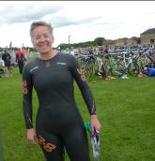
Registration – meant a race number, but also a green swim cap and stickers for my bike and helmet, and big numbers on my arm and leg (that took a lot of scrubbing later to get off). This was followed by a race briefing that was basically all about safety – a guy sadly died on the swim two years previously, so they take safety very seriously. Wetsuit on, swim cap on, I’m ready ...

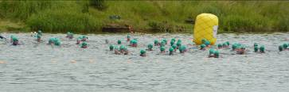
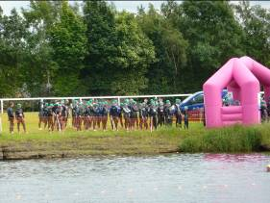
Swim (1.5km) – this event had a wave start, and being very slow and I was in the last wave, which meant that we had plenty of time to chat away while waiting to get in the water, and being the under-class, we all knew our place, and thus had no desire to try to impress anyone that we knew what we were doing! Once we started getting into the lake the fastest swimmers were already heading for the finish. We had a couple of minutes to acclimatise – which meant noticing that weeds weren’t going to grab me and drown me, or that water does smell of others things than chlorine!

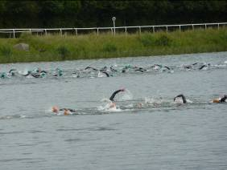
3, 2, 1 – we’re off. This was my first swim event, and I was ready for the ‘washing machine’ start, but being in waves, it actually wasn’t so frantic, and I just got into the zone, told myself to be calm, and well, basically got on with it. I did try drafting, which did seem to work – either that I actually was being pulled a little by the swimmer in front of me, or that I simply enjoyed the safety of feeling close to someone else.

This was the part of the day I was most anxious about, and fully expected to be last or nearly last out of the water. It was tiring, but I was happy with my swim, and only stopped once with a little swallowed water panic. Indeed there weren’t many behind me, but that did mean I wasn’t last either, so that was fine.

I wobbled a bit coming out, but we’d been told to expect that – marshals helped me find my feet, and one even unzipped me, but I was in far too much of a hurry to take them up and such a forward gesture!!

I expected to be out within the hour, and wanted to be sub 45, so was thrilled to see my swim time was 38 min. Slow in comparison to nearly everyone else, but far better than I had expected.

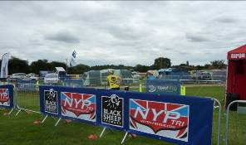
Transition 1 – Run across muddy grass to bike, which was easy to find because most of the bikes had gone! Wetsuit off, helmet on, shoes and T shirt on, then run with bike to the mount point. This bit went ok, although I did learn that while its just about doable to put one’s gloves on while cycling, putting a Garmin on one-handed is just not possible, so had to stop to do this.

Cycle (25km) – I was really out of breath for about 2 miles, so didn’t eat or drink, just concentrated on pedalling. After a while I started to settle, so started my feast of malt loaf, energy drinks and 2 gels (Torq – rhubarb and custard flavour, highly recommended). The cycle was just fab – this was my first cycle race, and what a treat to cycle on quiet roads, with marshals stopping the traffic for me. I really enjoyed myself. Against their advice, my local bike shop fitted aerobars on my bike the day before, as I knew that even though this was a race, it was also an opportunity to have long stretches of quiet, straight roads to have a go at the ‘TT tuck’. So I did, and it was great – I felt like a pro (well a bit). I even overtook 2 or 3 people.

I had no idea how to pace myself, and whilst I was enjoying pedalling quite fast, I wondered whether I should ease off and save something for the run, but just kept going anyway.

The dismount line seem to appear very suddenly and had to brake pretty quick and suddenly remember to unclick before attempting to get off.

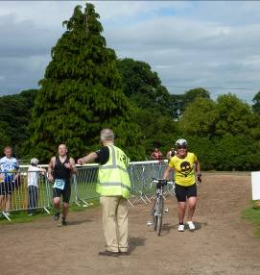
I aimed to get under 2 hours for the ride, so was thrilled with 1:35

Transition 2 – Running on a road in cycle shoes needs practice! (Yes, the guy next to me has already finished his run before I’ve even started!)

This bit was fine – cycling shoes off, hop about trying not to get feet muddy, put socks on (with a bit of help with some talc in socks), trainers on, then off. Oops – forgot to swivel race number from back to front – you get one reminder and then disqualified.

Run (10km) – Last gel and a quick swig of water then off. Quickly passed by 686 who looked great in her tri suit, I have to say. She didn’t pull away, though, and after a while I caught her up and we chatted a while. We then caught up with another female and the three of us ran together. I was aiming for a sub-60 so knew I had to keep under 9:40 min/miles, but my Garmin was telling me I was running much faster and was under 9 min/miles. I worried that I’d started out too fast and would fade later on. I didn’t, and even managed to pull away from 636, finishing the run with a 57:39, only 5 minutes slower than my standalone PB.

Summary – I’d told Carol I’d be disappointed if I took longer than 4 hours, but really hoped I’d come in under 3.45, so I couldn’t believe my final time of 3:10. Yes it was way slower than most of the field, but way faster than I expected.

The most important thing is that I had really enjoyed myself and am really keen to do another – perhaps a bit further next time ...!!
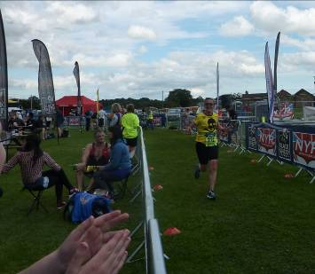

P.S. – Anders did well in his Kids Dash – he came about 15th, I think

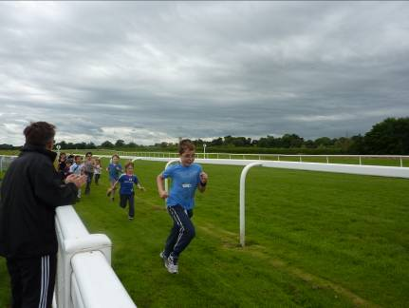

Olympic Torch

Sara took some photos of the torch coming through Hull ...

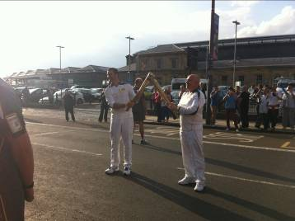
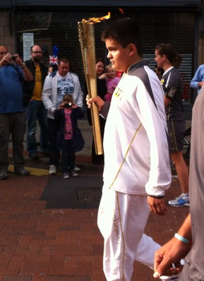
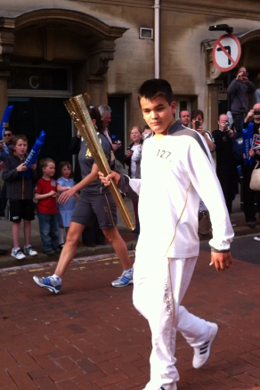
Racing and Running Events

Date | Event | Distance | Fee |  | Entry / website
21st 10.00 | Yorkshire Wolds ½ | ½ marathon | £11 | http://www.bishopwiltonshow.com/
22nd | Harrogate | 10k |  | www.harrogateharriers.co.uk
28-29th | Thunder Run | As far as you can! |  | www.tr24.co.uk
29th 10.30 | Idle Trail Race | 10k | £8 | www.idleac.co.uk
29th 10.00 | Elloughton 10k | 10k | £11/13 | http://www.runbritain.com/onlineentry/entry/jim-dingwall-10k-1/
August
5th 9.00 | Jane Tomlinson York | 10k | £24 |  | www.runforall.com
19th 11.00 | Escrick 10k | 10k | £9 |  | www.escrick10k.co.uk
25th 8.00 | Smugglers Trod | 17 or 25 ml | £8 |  | http://www.ldwa.org.uk/YorkshireCoast/W/1416/2012-smugglers-trod-entry-form.html
27th 10.30 | Askern 10 | 10 miles | £8 |  | www.askerndrc.org
September
1st 11.00 | 30th Lincs Wolds | 10 miles | £11 |  | http://www.woldsvets.co.uk/
8-14th | Transbritain Ultra | 156 miles | £750 |  | www.gobeyondultra.co.uk
9th 10.00 | Major Stone | 1/2 marathon | £14 |  | www.easthullharriers.com
October
6th 9.00 | Round Ripon Ultra | 35 miles | £39 or free |  | www.gobeyondultra.co.uk  Postal entries only see May 26th
7th 9.30 | Mablethorpe Marathon | ½ and full marathon | £27.50 for full |  | www.mablethorpemarathon.org.uk
21st 12pm | Bridlington Half | ½ marathon | £10 |  | www.bridlingtonrr.co.uk
28th 10.00 | Yorkshire Coast 10k | 10k | £11.50 |  | www.yorkshirecoast10k.co.uk
November
18th 9.00 | Valencia Marathon | Marathon | 45 Euros |  | www.maratonvalencia.com

** Dates/times are subject to change **
Keep checking the website for new races and updates: www.westhullladies.org.uk/races.htm Verity, Racing Officer

Chuckle Corner
(Cringe Corner?)

I'm in shape. Round is a shape.

The advantage of exercising everyday is that you die healthier.

Chocolate is a vegetable. How, you ask? Chocolate is derived from cacao beans. Bean = vegetable. Sugar is derived from either sugar CANE or sugar BEETS. Both are plants, which places them in the vegetable category. Thus, chocolate is a vegetable.

If swimming is good for your figure, explain whales to me.

NOTE: Club Vests must be worn at any races you enter
under the West Hull Ladies running club name.

Clubwear
PRICES:
Vest | £15.00 | All items are ordered on request and must  be paid for at time of ordering. To place an  order please get in touch via West  Hull Ladies e-mail and mark your emails  for the attention of Geri.
T- shirt | £16.50
Hoodie | £14.00
Jacket | £32



New Club Jacket available in three sizes: small, extra small, and junior (large fitting). If you would like to purchase one please send a cheque for £32 to Victoria Voase, Treasurer, and state on the back of your cheque your name and that the cheque is for a jacket.

Becca

Running Library

You can borrow any of these books – they are upstairs near the toilets at the end of the corridor
Book List:
- The Runner's Diet (Runners World), Madelyn H. Fernstrom
- Paula My Story So Far, Paula Radcliffe
- The Runner's Handbook, Bob Glover
- The Competitive Runner's Handbook, Bob Glover & Shelly Lynn Glover
- Marathon Running For Mortals, John Bingham

- Lore of Running,

Running Magazines: These are available to borrow by emailing the club website.
Mark your email for the attention of Becca.

